Supporting Information

P2-Type Layered High-Entropy Oxides as Sodium-Ion Cathode Materials

Junbo Wang,¹ Sören L. Dreyer,¹ Kai Wang,¹ Ziming Ding,¹ Thomas Diemant,² Guruprakash Karkera,² Yanjiao Ma,¹ Abhishek Sarkar,^{1,3} Bei Zhou,¹ Mikhail V. Gorbunov,⁴ Ahmad Omar,⁴ Daria Mikhailova,⁴ Volker Presser,^{5,6,7} Maximilian Fichtner,^{1,2} Horst Hahn,^{1,2,3} Torsten Brezesinski,¹ Ben Breitung,¹* and Qingsong Wang^{1,2}*

1 Institute of Nanotechnology, Karlsruhe Institute of Technology (KIT), Hermann-von-Helmholtz-Platz 1, 76344 Eggenstein-Leopoldshafen, Germany
2 Helmholtz Institute Ulm (HIU) Electrochemical Energy Storage, Helmholtzstrasse 11, 89081 Ulm, Germany
3 Joint Research Laboratory Nanomaterials – Technische Universität Darmstadt and Karlsruhe Institute of Technology (KIT), Otto-Berndt-Strasse 3, 64206 Darmstadt, Germany
4 Leibniz Institute for Solid State and Materials Research (IFW) Dresden, Helmholtzstrasse 20, 01069 Dresden, Germany
5 INM - Leibniz Institute for New Materials, Campus D2 2, 66123 Saarbrücken, Germany
6 Department for Materials Science and Engineering, Saarland University, Campus D2 2, 66123 Saarbrücken, Germany
7 Saarene, Saarland Center for Energy Materials and Sustainability, Campus C4 2, 66123 Saarbrücken, Germany
* E-mail: ben.breitung@kit.edu (B. Breitung), qingsong.wang@kit.edu (Q. Wang)

The configurational entropy, S_{config}, is based entirely on the number of different elements in the single-phase structure. S_{config} can be increased by increasing the number of elements, which are randomly distributed on the same lattice site(s). The molar configurational entropy can be calculated according to a Boltzmann-entropy-derived equation:

$$S_{config}=-R\left[{\sum_{i=1}^{M}{x_{i}ln{ x}_{i}}}_{cation-site}+{\sum_{j=1}^{N}{x_{j}\ln{x_{j}}}}_{anion-site}\right] (S1)$$
where R represent the ideal gas constant, and x_{i} and x_{j} are the molar fraction of cations or anions on the respective sublattices [DOI: 10.1002/adma.201806236, DOI: 10.1039/d1ee00505g, DOI: 10.1038/s41467-018-05774-5, DOI: 10.1038/ncomms9485].

Table S1. Structural parameters from Rietveld refinement analysis.
 | 3-NTMO₂ | 5-NTMO₂ | 7-NTMO₂
a = b / Å | 2.8607(1) | 2.8729(1) | 2.8781(1)
c / Å | 11.1343(4) | 11.1443(6) | 11.1542(5)
V / Å³ | 78.910(4) | 79.587(5) | 79.876(4)
R_{p} / % | 1.19 | 1.35 | 1.26
R_{wp} / % | 1.56 | 1.99 | 1.73

Table S2. ICP-OES results for the synthesized materials.
Targeted composition | Experimentally determined composition
Na_{0.67}(Mn_{0.55}Ni_{0.21}Co_{0.24})O₂ | Na_{0.6510}(Mn_{0.5336}Ni_{0.2058}Co_{0.2293})O₂
Na_{0.67}(Mn_{0.45}Ni_{0.18}Co_{0.24}Ti_{0.1}Mg_{0.03})O₂ | Na_{0.6666}(Mn_{0.4467}Ni_{0.1817}Co_{0.2340}Ti_{0.0933}Mg_{0.0254})O₂
Na_{0.67}(Mn_{0.45}Ni_{0.18}Co_{0.18}Ti_{0.1}Mg_{0.03}Al_{0.04}Fe_{0.02})O₂ | Na_{0.6649}(Mn_{0.4433}Ni_{0.1806}Co_{0.1763}Ti_{0.0947}Mg_{0.026}Al_{0.037}Fe_{0.016})O₂

Table S3. Summary of the DEMS results.
Material | 1st cycle charge capacity (mAh g⁻¹) | 1st cycle discharge capacity (mAh g⁻¹) | 2nd cycle charge capacity (mAh g⁻¹) | 2nd cycle discharge capacity (mAh g⁻¹) | 2nd cycle Coulombic efficiency (%) | 1st cycle total H₂ (µmol g⁻¹) | 1st cycle total CO₂ (µmol g⁻¹) | 2nd cycle total H₂ (µmol g⁻¹) | 2nd cycle total CO₂ (µmol g⁻¹)
3-NTMO₂ | 160 | 191 | 197 | 189 | 95.9 | 60 | 315 | 20 | 57
5-NTMO₂ | 156 | 177 | 183 | 178 | 97.3 | 76 | 380 | 27 | 45
7-NTMO₂ | 146 | 172 | 178 | 177 | 99.4 | 54 | 300 | 26 | 36

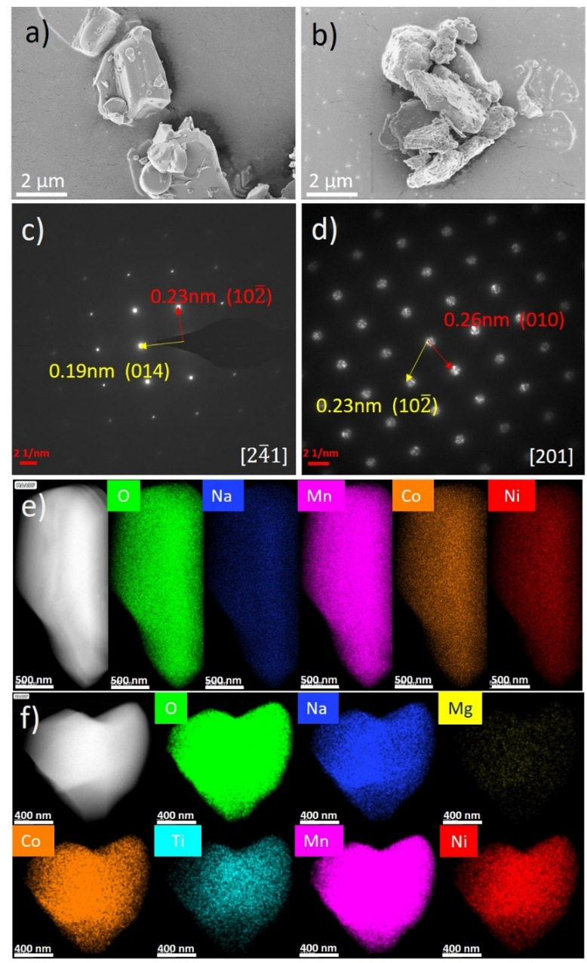
Figure S1. a, b) SEM images, c, d) SAED patterns along [$2\overline{4}1$] and [$201$] and e, f) HAADF-STEM image and corresponding high-resolution EDX maps for 3-NTMO₂ and 5-NTMO₂, respectively.

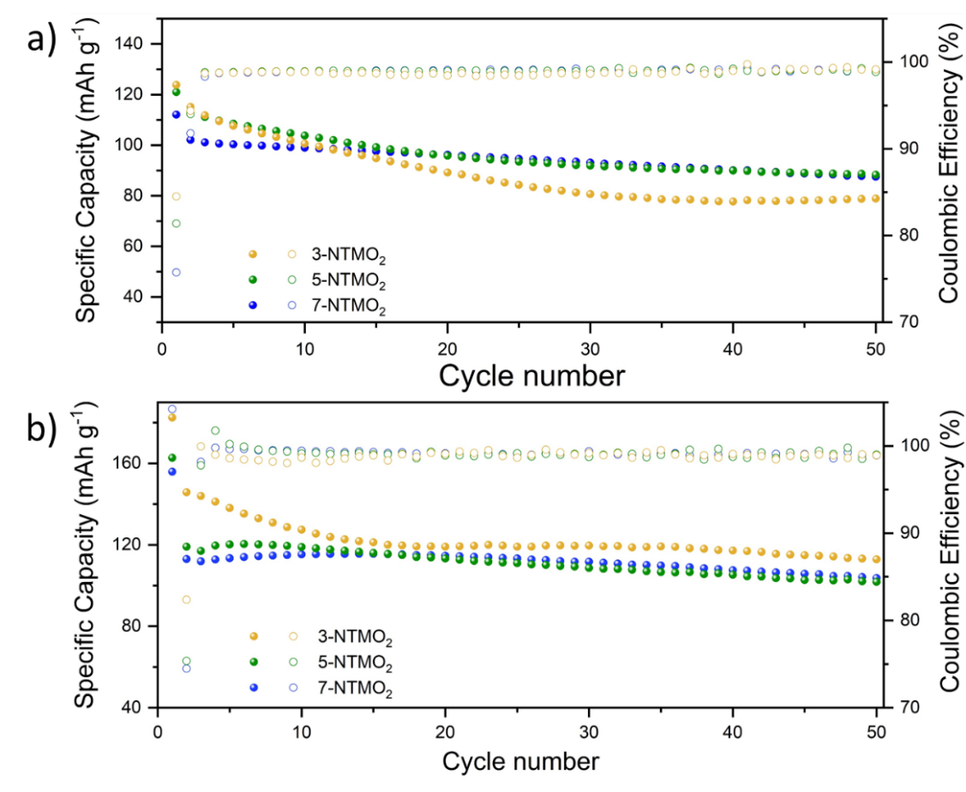
Figure S2. Cycling performance of 3-NTMO₂, 5-NTMO₂ and 7-NTMO₂ in the voltage range of a) 2.6-4.6 V and b) 1.5-4.6 V. Electrochemical testing was carried out at room temperature and 0.5C rate over 50 cycles.

Figure S2a shows the cycling performance of the materials in the voltage range 2.6-4.6 V at 0.5C rate. Despite higher initial specific capacities, the 3-NTMO₂ and 5-NTMO₂ electrodes show obvious decay in the first 15 cycles. After that, the trend towards lower specific capacity is not alleviated for 3-NTMO₂, while it tends to be moderate for 5-NTMO₂. In contrast, the 7-NTMO₂ electrode exhibits superior cycling stability. The cycling performance of the materials in the voltage range 1.5-4.6 V at 0.5C rate is shown in Figure S2b. A similar trend in capacity degradation is observed as that found in the range of 2.6-4.6 V. However, the cell with the 3-NTMO₂ delivers a higher specific capacity (113 mA h g⁻¹) after 50 cycles than 5-NTMO₂ and 7-NTMO₂. The higher discharge capacities are due to the Mn⁴⁺/Mn³⁺ redox couple, leading to fast working voltage decay and low capacity retention. In contrast, the 5-NTMO₂ and 7-NTMO₂ electrodes display slower fading, with remaining specific capacities of 102 and 104 mA h g⁻¹ after 50 cycles, corresponding to 63 % and 67 % capacity retention, respectively.

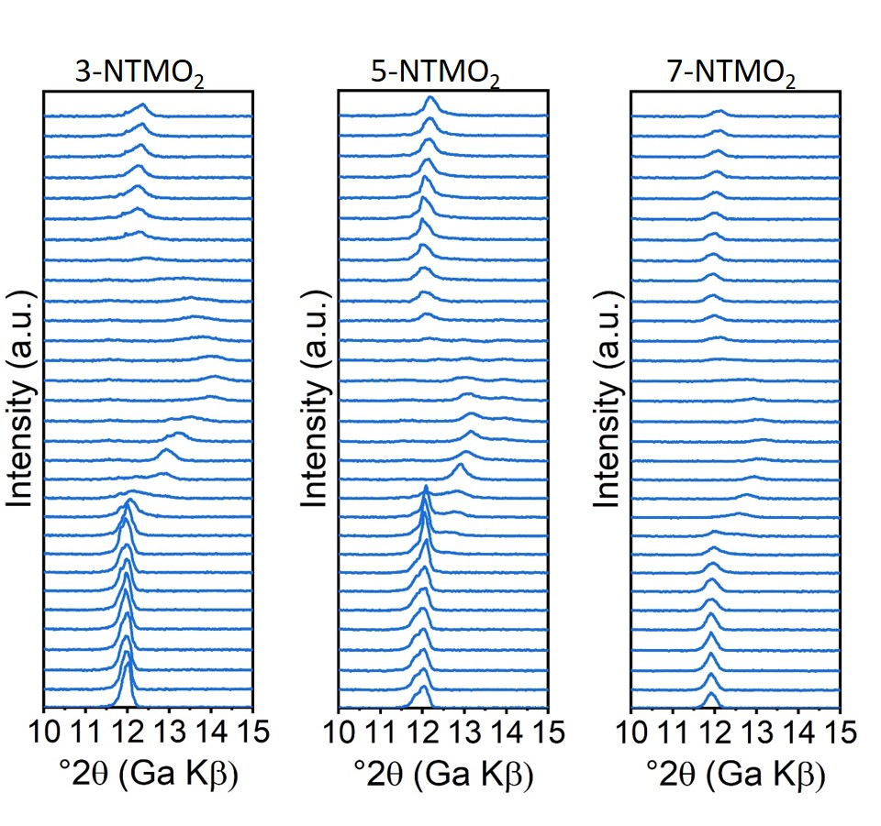
Figure S3. Operando XRD data between 6 and 26 h, where desodiation and resodiation proceed at high voltages (> 4.2 V vs. Na⁺/Na).

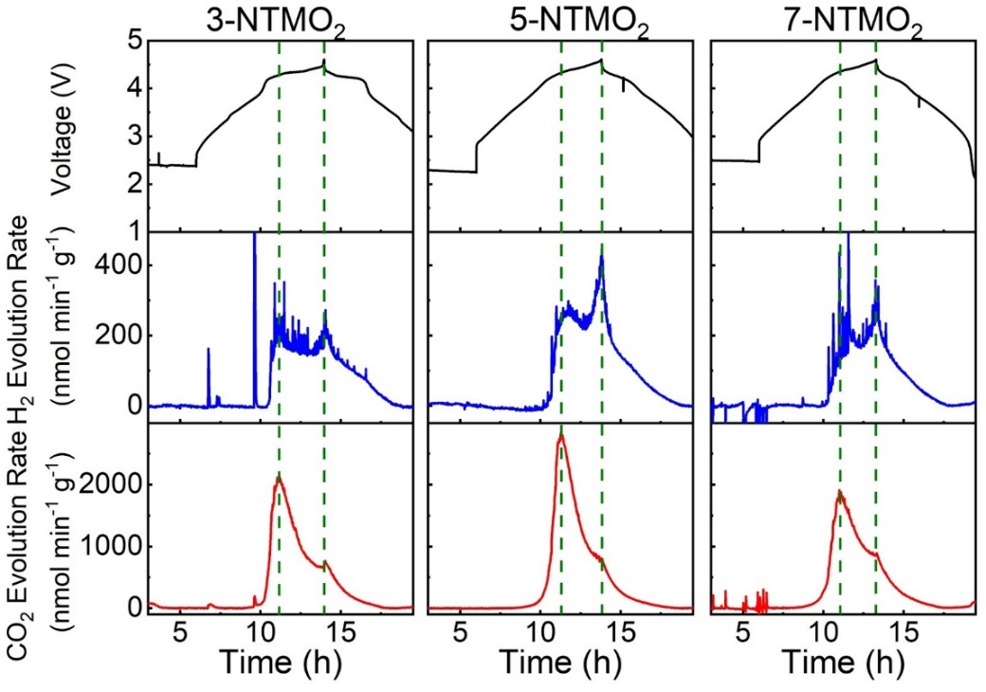
Figure S4. Carbon dioxide and hydrogen evolution rates from DEMS in the first cycle for the 3-NTMO₂, 5-NTMO₂ and 7-NTMO₂ electrodes.

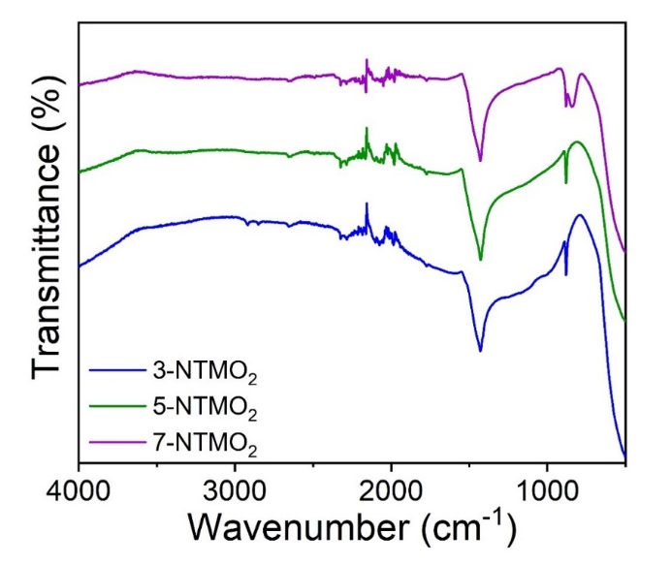
Figure S5. FT-IR spectra of the as-prepared 3-NTMO₂, 5-NTMO₂ and 7-NTMO₂ powders.

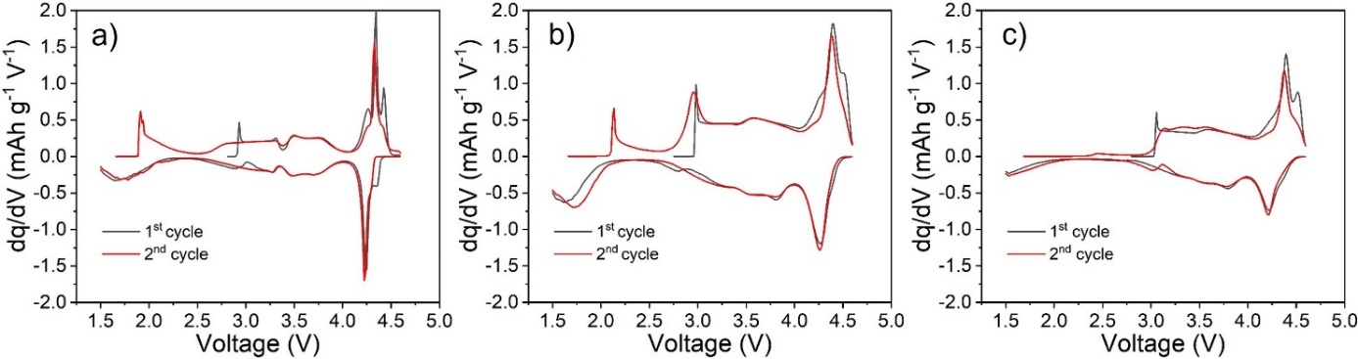
Figure S6. Differential capacity plots (dq/dV) of the first two cycles at 0.05C rate and 25 °C for the a) 3-NTMO₂, b) 5-NTMO₂ and c) 7-NTMO₂ electrodes.

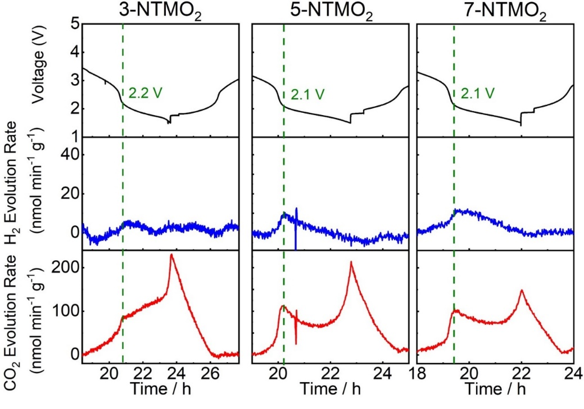
Figure S7. Carbon dioxide and hydrogen evolution rates from DEMS in the first discharge cycle for the 3-NTMO₂, 5-NTMO₂ and 7-NTMO₂ electrodes.

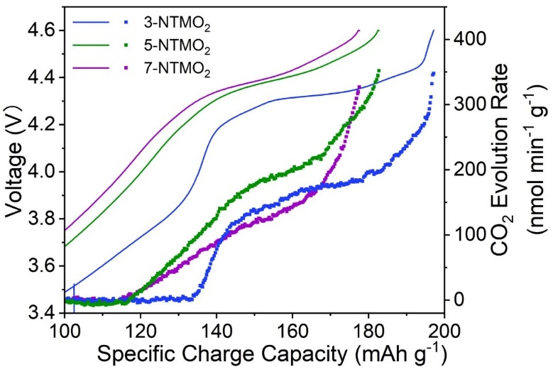
Figure S8. Carbon dioxide evolution rates and voltage as a function of specific charge capacity in the 2nd cycle.

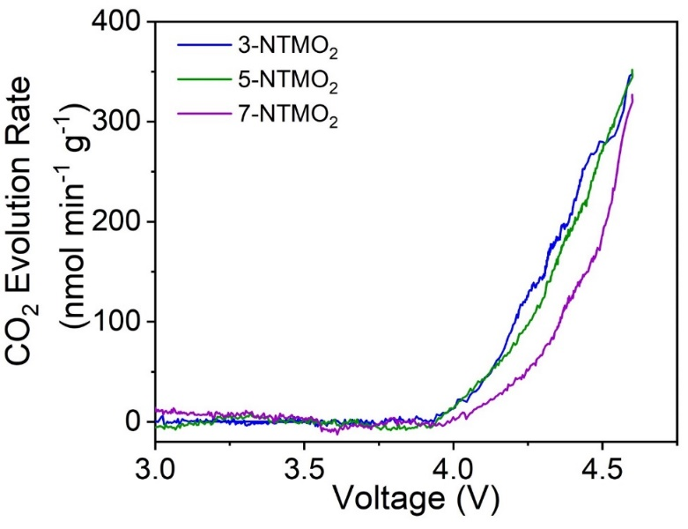
Figure S9. Carbon dioxide evolution rates as a function of voltage in the 2nd cycle.

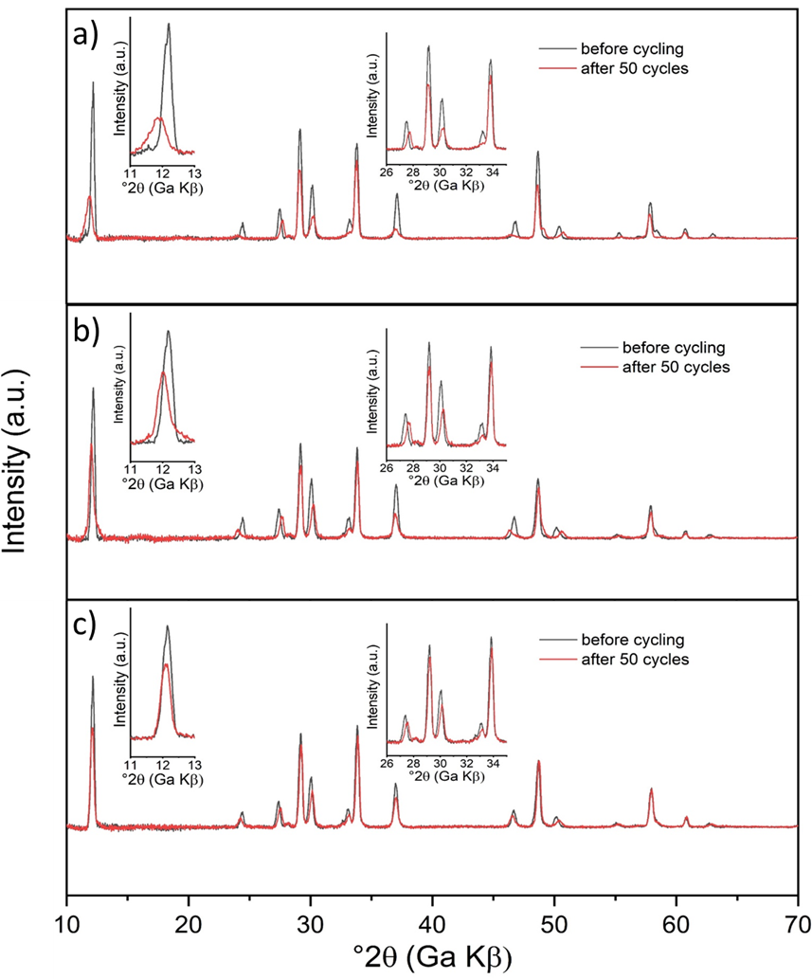
Figure S10. Ex situ XRD patterns for a) 3-NTMO₂, b) 5-NTMO₂ and c) 7-NTMO₂ in the pristine state and after discharge in the 50th cycle.

Figure S11. XPS spectra of the Mn 2p region for the 3-NTMO₂, 5-NTMO₂ and 7-NTMO₂ electrodes prior to cycling.

